Python Programming Lab Task Sets
SET 4
- Algorithms
Q) Use AI to generate Python code for Bubble Sort and Insertion Sort.
Prompt: Generate optimized and well-commented Python implementations of Bubble Sort and Insertion Sort. Include time complexity analysis for each algorithm, a comparison of best/average/worst cases, and example code showing how to call each function.
Ensure the code is easy for beginners to understand."

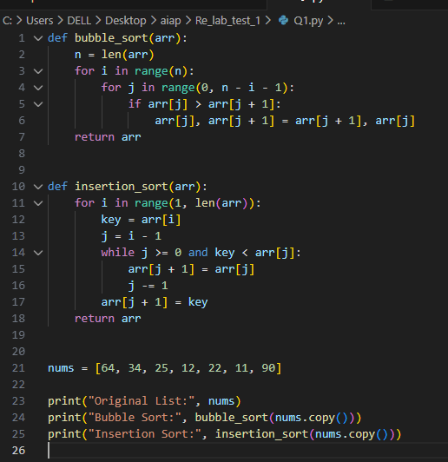

Output:
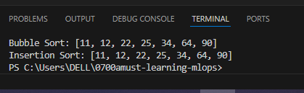

- Compare their execution time using Python's time module
Prompt: Write Python code to compare the execution time of Bubble Sort and Insertion Sort using the time module.
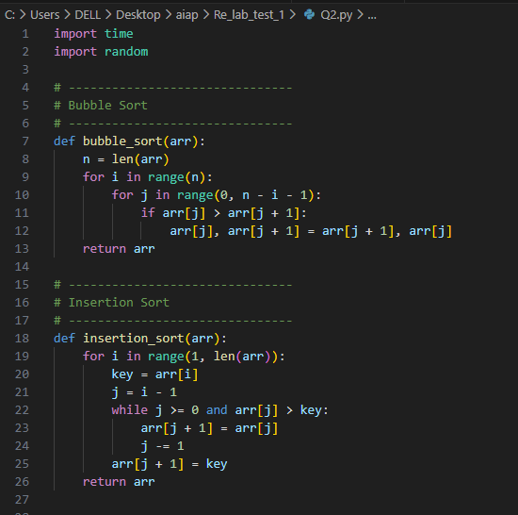
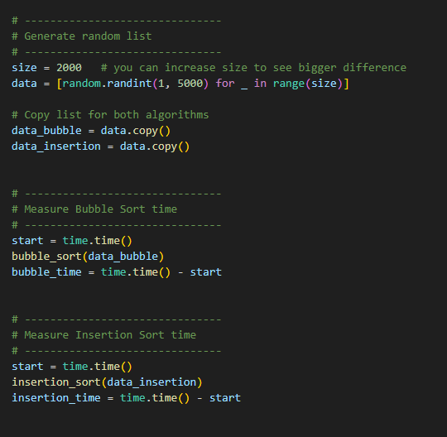
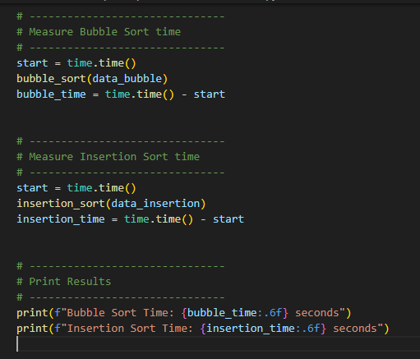

Output:

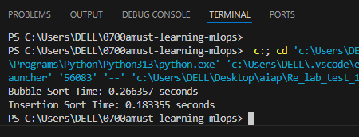

Q) With AI help, create a webpage showing a dynamic product list using JavaScript arrays.
Each product must display:
- Name
- Price
- "Add to Cart" button
Prompt: Create a complete HTML, CSS, and JavaScript code for a webpage that displays a dynamic product list using a JavaScript array. Each product should show its Name, Price, and an 'Add to Cart' button. The products must be stored in a JavaScript array and displayed dynamically on the webpage. When the user clicks 'Add to Cart', show an alert saying 'Added to cart'. Make the design simple and clean.
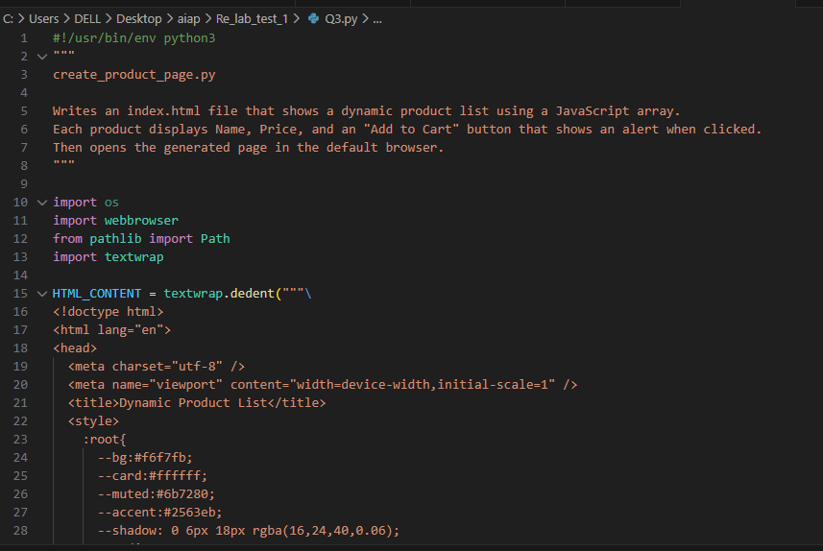

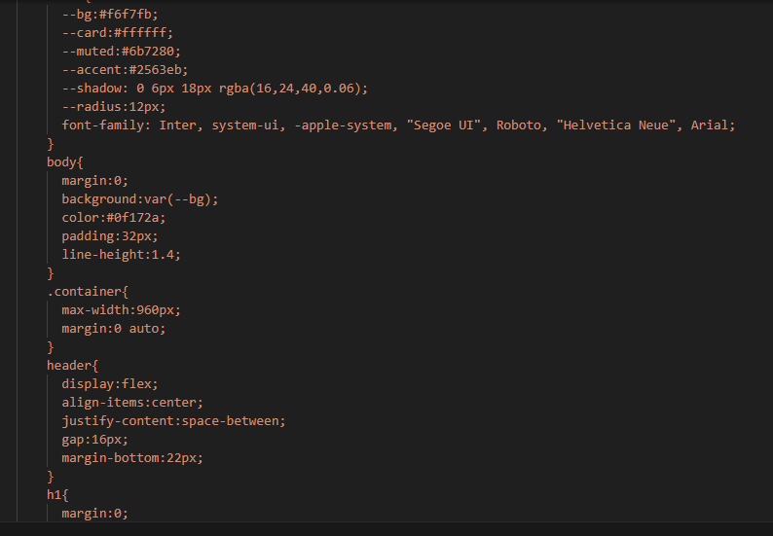
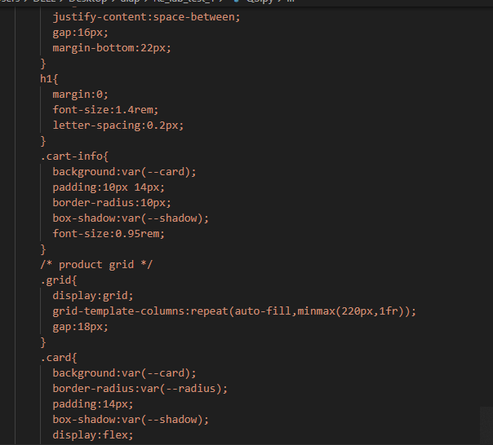
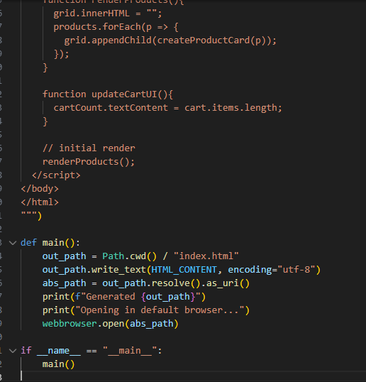

Output:
